***Climada* module GDP_entity**  22 Feb 2016

<https://github.com/davidnbresch/climada_module_country_risk>

Lea Mueller, [muellele@gmail.com](mailto:muellele@gmail.com)

David Bresch [david.bresch@gmail.com](mailto:david.bresch@gmail.com)

Create a default asset base for a specific country, consisting of centroids (used later e.g. to generate a hazard event set of matching resolution) and assets scaled to the country GDP for today and future[1].

All in one, just type:

**[centroids,entity,entity_future]=...  
 climada_create_GDP_entity(country_name)**

Example: **[centroids,entity,entity_future]=...  
 climada_create_GDP_entity('Dominican Republic')**

and consult **help climada_create_GDP_entity**

See also the module country risk, which runs all (available) perils for one country[2].

Contents

Part 1: All-in-one functions 3

1. All-in-one functions 3

1a) Create centroids and base entity for a country 3

1b) GDP based entity for a certain region within a country 3

Part 2: Background information and individual functions 4

2. Night time lights for spatial distribution of values 4

3. Gross Domestic Product (GDP) data 7

3a) GDP today 7

3b) Future projection of GDP 10

4. Countries: Use polygons and rasters as helper files 12

5. Night light intensities as a proxy for spatial distribution of values within a country: Linear or nonlinear relationship between light intensity and asset value 13

6. Create the centroids 16

6a) Define the resolution 16

6b) Cut out coastal areas (hollow out) and expand with a buffer zone 17

6c) Create the centroids 18

7. Create the entity 20

7a) Base entity: assets sum up to 100 for a given country 20

7b) Entity with assets based on the country's GDP today 22

7c) Future entity with assets based on the country's future GDP (e.g. 2030) 23

7d) Select a specific region within a country 24

8. Appendix 26

8a) Downscale resolution of original night light tif in ArcGIS 26

8b) Night light and GDP relationship 26

# Part 1: All-in-one functions

## All-in-one functions

### Create centroids and base entity for a country

The following function creates a portfolio for a specific country, consisting of the base entity and centroids.

**[centroids,entity_base]=...**

**climada_create_centroids_entity_base(country_name)**

All input parameters are optional. If not given as an input, the country can be selected through a graphical user interface. The required resolution can be specified as a value in km; however default value is roughly 10 km. Per default, the base entity and centroids will be saved in the folders ..\climada\data\entities and ..\climada\data\centroids, respectively. Please note that the damagefunction information is only added if the entity template is found in ..\climada\data\entities\entity_template.xls , otherwise an entity without damagefunctions is generated (in this case, read damagefunctions e.g. from another entity, using e.g. climada_damagefunctions_read)

### GDP based entity for a certain region within a country

The function climada_create_GDP_entity wraps it all in one function. It creates a portfolio with centroids, as an intermediary step creates the base entity, and scales the entity assets up to GDP today and future GDP projection.

**[centroids, entity, entity_forecast] =… climada_create_GDP_entity(country_name)**

# Part 2: Background information and individual functions

## Night time lights for spatial distribution of values

Stable night time lights can be downloaded from NOAA, e.g. the data for 2010, Version 4 DMSP-OLS Night time Lights Time Series

<http://ngdc.noaa.gov/eog/dmsp/downloadV4composites.html#AVSLCFC>[3]

The files are cloud-free composites made using all the available archived DMSP-OLS smooth resolution data for calendar years. In cases where two satellites were collecting data - two composites were produced. The products are **30 arc second grids**, spanning -180 to 180 degrees longitude and -65 to 75 degrees latitude.

Credit: Image and data processing by NOAA's National Geophysical Data Center. DMSP data collected by US Air Force Weather Agency

A number of constraints are used to select the highest quality data for entry into the composites:

* Data are from the center half of the 3000 km wide OLS swaths. Lights in the center half have better geolocation, are smaller, and have more consistent radiometry.
* Sunlit data are excluded based on the solar elevation angle.
* Glare is excluded based on solar elevation angle.
* Moonlit data are excluded based on a calculation of lunar illuminance.
* Observations with clouds are excluded based on clouds identified with the OLS thermal band data and NCEP surface temperature grids.
* Lighting features from the aurora have been excluded in the northern hemisphere on an orbit-by-orbit manner using visual inspection.

Each composite set is named with the satellite and the year (F121995 is from DMSP satellite number F12 for the year 1995). Three image types are available as geotiffs for download from the version 4 composites:

* **F1?YYYY_v4b_stable_lights.avg_vis.tif**: The cleaned up avg_vis contains the lights from cities, towns, and other sites with persistent lighting, including gas flares. Ephemeral events, such as fires have been discarded. Then the background noise was identified and replaced with values of zero. **Data values range from 1-63**. Areas with zero cloud-free observations are represented by the value 255.

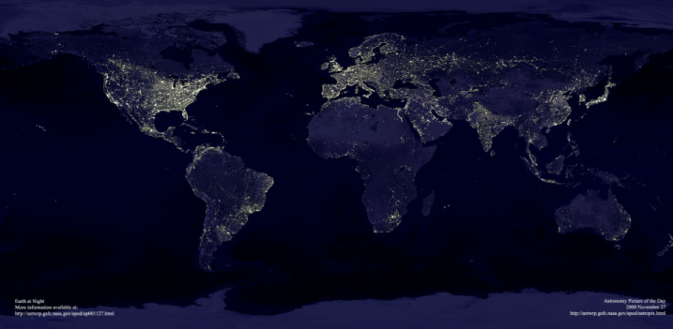Figure 1: Night time lights( "Nighttime Lights.bmp") in 2010. Credit: Image and data processing by NOAA's National Geophysical Data Center. DMSP data collected by US Air Force Weather Agency.

The downloaded tif file is too big to be read directly in matlab, therefore resample (downscale resolution) in ArcGIS. See Appendix for further information on resampling in ArcGIS. Save in png-file format ...\climada_additional\2_globalGDP\data\night_light_2010_10km.png

Read stable night light in matlab and save variable as "night_light_2010_10km.mat" (1680 x 4320 cells, 10km resolution) in ...\climada_additional\2_globalGDP\data\night_light_2010_10km.mat

|  |  |  |  |
| --- | --- | --- | --- |
| MATLAB call: | | | |
|  | night_light = | climada_night_light_read(png_filename,check_figure, check_printplot, save_on)  climada_night_light_read('night_light_2010_10km.png') | |
|  |  | *.values* | *1680x4320 sparse double indicating night light intensities in the range 180 to 180 degrees longitude and -65 to 75 degrees latitude* |
|  |  | *.lon_range* | *Longitudinal range of masks, e.g. [-180 180]* |
|  |  | *.lat_range* | *Latitudinal range of masks, e.g. [-65 75]* |
|  |  | *.resolution_x* | *Resolution in x direction in degree, e.g. 0.0833°, corresponds roughly to 10km* |
|  |  | *.resolution_y* | *Resolution in y direction in degree, e.g. 0.0833°, corresponds roughly to 10km* |
|  |  | *.comment* | *Night time lights, 2010* |

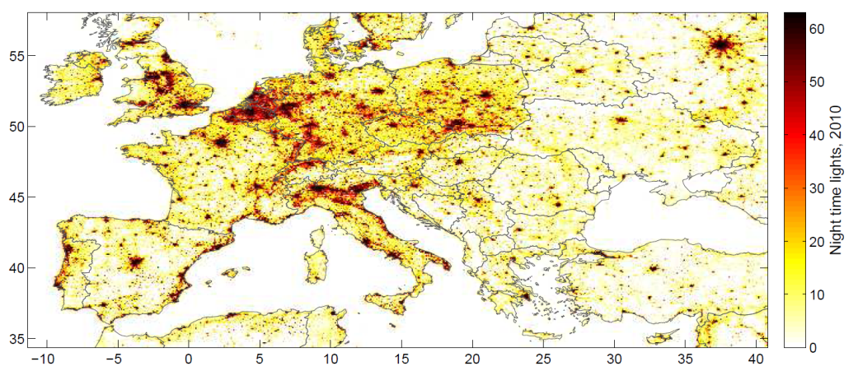Figure 2: Stable night lights in matlab (1680 x 4320 cells, 10km resolution), zoomed to Europe.

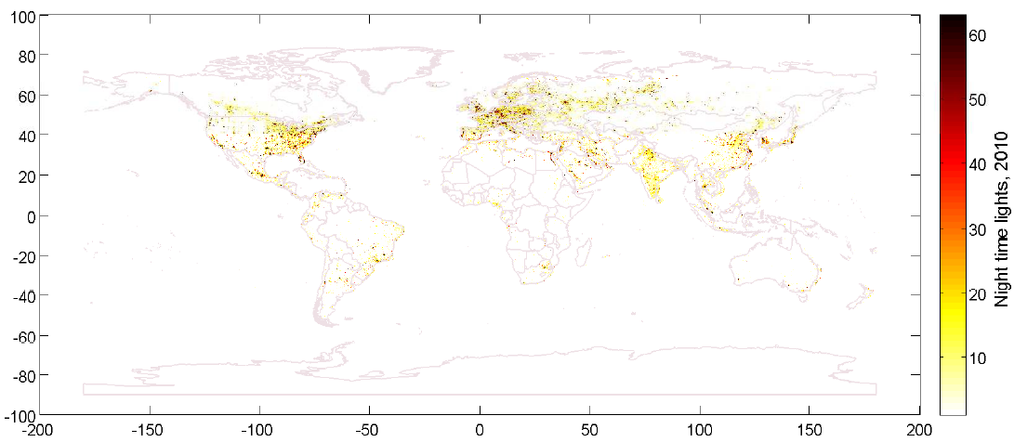Figure 3: Stable night lights in matlab (1680 x 4320 cells, 10km resolution) on a global scale.

## Gross Domestic Product (GDP) data

### GDP today

GDP Data is available from the World Bank

<http://data.worldbank.org/indicator/NY.GDP.MKTP.CD>

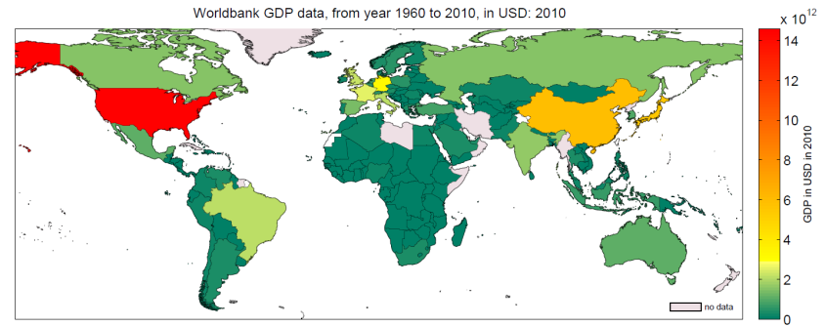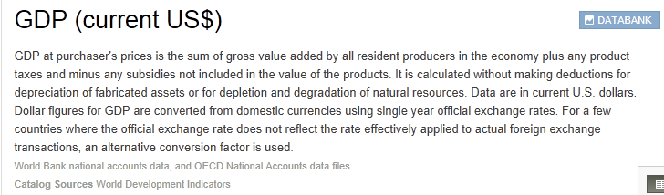Figure 4: GDP Data from Worldbank Website, July 2012. [*http://data.worldbank.org/indicator/NY.GDP.MKTP.CD/countries*](http://data.worldbank.org/indicator/NY.GDP.MKTP.CD/countries)

Figure 5: GDP 2010 per country.

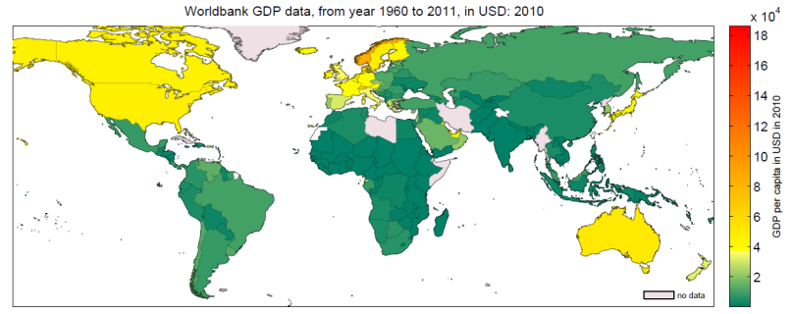

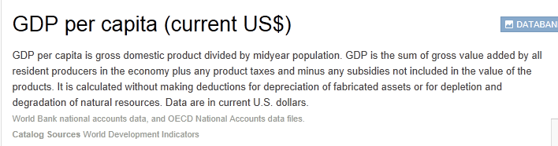Figure 6: GDP per capita data from Worldbank Website, July 2012.

[*http://data.worldbank.org/indicator/NY.GDP.PCAP.CD/countries*](http://data.worldbank.org/indicator/NY.GDP.PCAP.CD/countries)

Figure 7: GDP 2010 per capita.

Use the excel file as a key to match country names of the World Bank with climada world map

..\climada_additional\ GDP_entity \data\country_names_key_between_worldbank_and_worldmap.xlsx

|  |  |  |  |
| --- | --- | --- | --- |
| MATLAB call: | | | |
|  | GDP = | climada_GDP_read(xlsfilename,special_cases_on, check_names, save_on, silent_mode)  climada_GDP_read('World_GDP_current_1960_2010.xls') | |
|  |  | *.country_names* | *216x1 cell, list with all country names, e.g. Afghanistan, Albania etc.* |
|  |  | *.year* | *1x51 double, with years from 1960 to 2010* |
|  |  | *.value* | *216x51 double, GDP value per year and country* |
|  |  | *.description* | *GDP in USD* |
|  |  | *.comment* | *World Bank/IMF GDP data, from year 1960 to 2010* |
|  |  | *.country_borders_index* | *216x1 cell, index that links GDP with border mask structure (see next chapter), e.g. GDP.country_borders_index{1) = 52; country number 1 in GDP list is Afghanistan and is on position 51 in the borders structure. One country in the GDP list can index to multiple countries in the border mask structure, for instance GDP India (position 88) refers to border masks position 55 (Kashmir and Jammu (claimed by India and Pakistan) and 100 (India).* |

Output

***

GDP in USD

Worldbank/IMF GDP data, from year 1960 to 2010

read successfully and loaded into workspace

GDP available for 216 countries

***

***

Check country names...

Climada world border file loaded to compare country names.

- GDP Australia is applied to

Christmas Island, Cocos (Keeling) Islands, Australia, Norfolk Island, Heard Island and Mcdonald Islands

39: no match found for GDP country name Channel Islands

- GDP China is applied to

Aksai Chin (administered by China. Claimed by India), China, Taiwan

- GDP France is applied to

Saint Pierre and Miquelon, France, Martinique, French Guyana, Wallis and Futuna Islands, Reunion, Europa Islands, French Southern Territories

74: no match found for GDP country name Gibraltar

- GDP India is applied to

Kashmir and Jammu (claimed by India and Pakistan), India

93: no match found for GDP country name Isle of Man

- GDP Israel is applied to

Golan Heights, Israel, Gaza Strip

104: no match found for GDP country name Kosovo

116: no match found for GDP country name Macao SAR, China

121: no match found for GDP country name Maldives

131: no match found for GDP country name Monaco

133: no match found for GDP country name Montenegro

- GDP Morocco is applied to

Morocco, Western Sahara

- GDP New Zealand is applied to

Cook Islands, New Zealand

- GDP Norway is applied to

Jan Mayen, Svalbard, Norway

- GDP Russia is applied to

Russia, Kuril Islands (administered by Russia. Claimed by Japan)

171: no match found for GDP country name Sint Maarten (Dutch part)

177: no match found for GDP country name South Sudan

- GDP Turkey is applied to

Turkey, Cyprus Turkish part

- GDP United Kingdom is applied to

United Kingdom, Virgin Islands (British), Anguilla, Montserrat, British Indian Ocean Territory, Saint Helena, Pitcairn, Falkland Islands (Malvinas), South Georgia and South Sandwich Islands

- GDP United States (USA) is applied to

United States (USA), Wake Island, Palmyra Atoll, Jarvis

|  |  |  |
| --- | --- | --- |
| MATLAB call: | | |
|  | GDP = | climada_GDP_check_countrynames(GDP, borders, silent_mode) |

Output

GDP country name matched for 239 countries within climada world map.

No GDP information available for following 4 countries (within climada worldmap):

- Antarctica

- Bouvet Island

- Nauru

- Niue

### Future projection of GDP

GDP development data is available from the International Monetary Fund, World Economic Outlook Database 2012 and from the European Central Bank

[www.imf.org/external/ns/cs.aspx?id=28](http://www.imf.org/external/ns/cs.aspx?id=28)

[www.imf.org/external/pubs/ft/weo/2012/01/weodata/index.aspx](http://www.imf.org/external/pubs/ft/weo/2012/01/weodata/index.aspx)

[www.ecb.int/home/html/index.en.html](http://www.ecb.int/home/html/index.en.html)

Gross domestic product, current prices, U.S. dollars, GDP growth until 2010, 2011

<http://data.worldbank.org/indicator/NY.GDP.MKTP.KD.ZG>

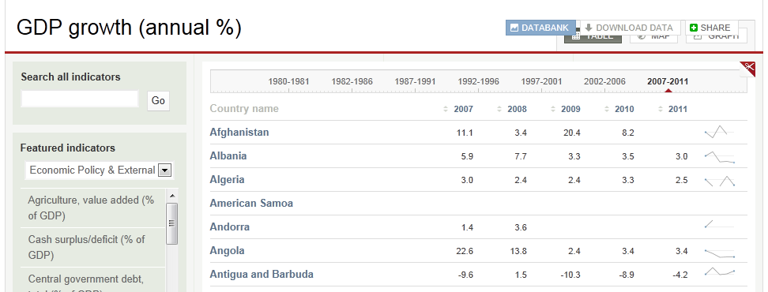

Figure 8: GDP growth data from world bank.

GDP projection data from 2010 to 2017 can be read from the excel file (GDP evolution from International Monetary Fund (IMF)), that is saved in

…\GDP_entity\data\World_GDP_2010_2017.xlsx

|  |  |  |  |
| --- | --- | --- | --- |
| MATLAB call: | | | |
|  | GDP_forecast = | climada_GDP_read(xlsfilename,special_cases_on, check_names, save_on, silent_mode)  climada_GDP_read('World_GDP_constant_2000_2017.xls') | |
|  |  | *.country_names* | *216x1 cell, list with all country names, e.g. Afghanistan, Albania etc.* |
|  |  | *.year* | *1x51 double, with years from 2000 to 2017* |
|  |  | *.value* | *216x51 double, GDP value per year and country* |
|  |  | *.description* | *constant GDP in national currency* |
|  |  | *.comment* | *IMF GDP data, from year 2010 to 2017* |
|  |  | *.country_borders_index* | *216x1 cell, index that links GDP with border mask structure (see next chapter), e.g. GDP.country_borders_index{1) = 52; country number 1 in GDP list is Afghanistan and is on position 51 in the borders structure. One country in the GDP list can index to multiple countries in the border mask structure, for instance GDP India (position 88) refers to border masks position 55 (Kashmir and Jammu (claimed by India and Pakistan) and 100 (India).* |

We extrapolate a future GDP based on the GDP forecast data by IMF (current price, national currency) with a second order polynomial. A scaleup factor is calculated on the basis of a linear extrapolation between today and the specified year in the future.

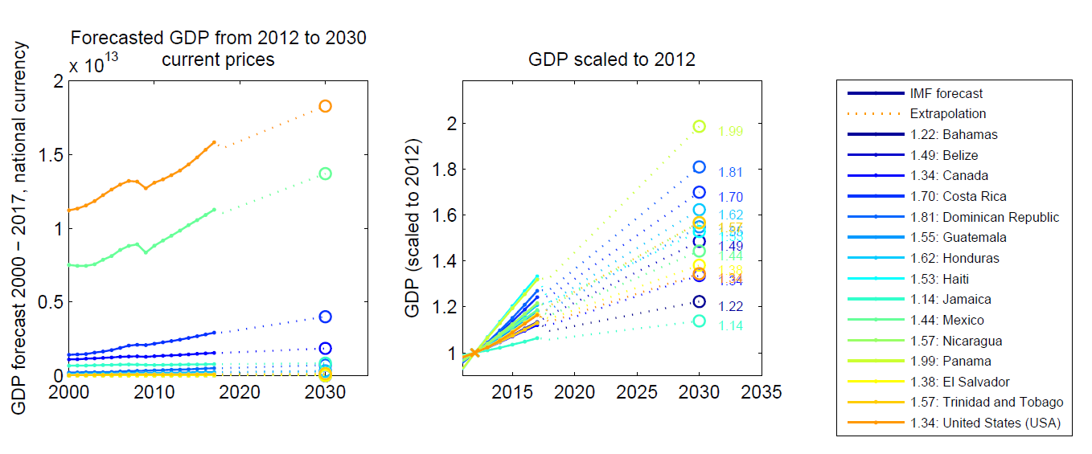

Figure 9: GDP development forecast from 2012 to 2030 for countries in North America. Forecast data until 2017 is available from IMF (GDP current prices, national currency).

## Countries: Use polygons and rasters as helper files

The climada world map is based on the text file world_50m.gen that is stored in the system folder

..\climada\data\system\world_50m.gen

A matlab variable is generated the first time from the gen-file while running the code climada_plot_world_borders. The mat-file is a structure variable and consists a list of country names, and according polygons. ..\climada\data\system\world_50m.mat

|  |  |  |
| --- | --- | --- |
| **MATLAB call:** | | |
|  | [varagout]= | climada_plot_world_borders(linewidth,check_country, map_border_file, keep_boundary, country_color) |

We create a raster for every country polygon on given lat-long-range and cellsize, size 1680 x 4320, filled with zeros and ones (one for within country, zero for out of country). This resolution corresponds roughly to 10 km. This takes a bit of time. For ~50km resolution (raster size 336 x 864) the function is a lot faster (roughly 2min). All country rasters are saved as border_mask.mat structure in ..\climada_additional\GDP_entity\data\border_mask_10km.mat

or ..\climada_additional\ GDP_entity \data\border_mask_50km.mat

|  |  |  |  |
| --- | --- | --- | --- |
| MATLAB call: | | | |
|  | border_mask= | climada_polygon2raster(borders,raster_size,save_on)  climada_polygon2raster('',[336 864]) | |
|  |  | *.mask* | *243 matrices (for each country) masking 1 for within country and zero for out of the country* |
|  |  | *.name* | *Name of each country* |
|  |  | *.world_mask* | *All countries within one mask (1 for land, 0 for sea)* |
|  |  | *.lon_range* | *Longitudinal range of masks, e.g. [-180 180]* |
|  |  | *.lat_range* | *Latitudinal range of masks, e.g. [-65 75]* |
|  |  | *.resolution_x* | *Resolution in x direction in degree, e.g. 0.0833°, corresponds to ~10km* |
|  |  | *.resolution_y* | *Resolution in y direction in degree, e.g. 0.0833°, corresponds to ~10km* |

|  |  |
| --- | --- |
| Figure 10: Raster or Canada polygons. Saved in  border_mask.mask{country_Canada} | Figure 11: Mask (zeros and ones) of the whole world. Resolution roughly 50km, 336*864 pixels. |

## Night light intensities as a proxy for spatial distribution of values within a country: Linear or nonlinear relationship between light intensity and asset value

We use the following function to identify the night light intensities within a country (given through the country mask) and to assign the values according to night light intensities.

The relationship between light intensities and asset values can be linear or nonlinear and in the latter case can be inputted through the factor pp. The factor pp describes the variables of a second order polynomial function without y-indent, such as y = pp(1)*x2+ pp(2)*x, where y is the asset value and x is the night light intensities (a value between 1 and 63). To use a linear relationship set pp to pp = [1 0]. pp is optional. If pp is not given, a standard nonlinear relationship is used, which is y = −0.0817*x + 0.0172*x2. The sum of all values distributed within a country is set to 100, i.e.

>> sum(full(values_distributed.values(:)))

ans =

100.0000

Like this, the values can easily be up scaled to any required value, such as GDP for a given year or any other value.

|  |  |  |  |
| --- | --- | --- | --- |
| MATLAB call: | | | |
|  | [values_distributed, pp]= | climada_night_light_to_country(country_name, pp, night_light, borders, border_mask, check_figure, check_printplot, save_on, silent_mode)  climada_night_light_to_country('Switzerland',[1 0])  climada_night_light_to_country('Switzerland') | |
|  | values_distributed is a structure with the following fields | | |
|  |  | *.values* | *1680x4320 sparse matrix, distribution of values within the range indicated in lon_range and lat_range, ~10km resolution* |
|  |  | *.lon_range* | *Longitudinal range of masks, e.g. [-180 180]* |
|  |  | *.lat_range* | *Latitudinal range of masks, e.g. [-65 75]* |
|  |  | *.resolution_x* | *Resolution in x direction in degree, e.g. 0.0833°, corresponds to ~10km* |
|  |  | *.resolution_y* | *Resolution in y direction in degree, 0.0833°, corresponds to ~10km* |
|  |  | *.comment* | *e.g. nonlinear function, y = 0.0000*x^0 + -0.0817*x^1 + 0.0172*x^2* |

And in there the function transforms the night lights to asset values.

|  |  |  |
| --- | --- | --- |
| MATLAB call: | | |
|  | [values_out, pp]= | climada_nightlight_nonlinear_transformation (values_in, pp, check_figure, check_printplot) |

|  |  |
| --- | --- |
| Figure 12: Distributed values within Switzerland on the basis of a linear relationship between night light intensities and asset values.  The sum of all values corresponds to 100. This value distribution forms the basis for a given scaling, e.g. based on a country's GDP. | Figure 13: Distributed values within Switzerland on the basis of a nonlinear relationship between night light intensities and asset values.  The sum of all values corresponds to 100. This value distribution forms the basis for a given scaling, e.g. based on a country's GDP. |

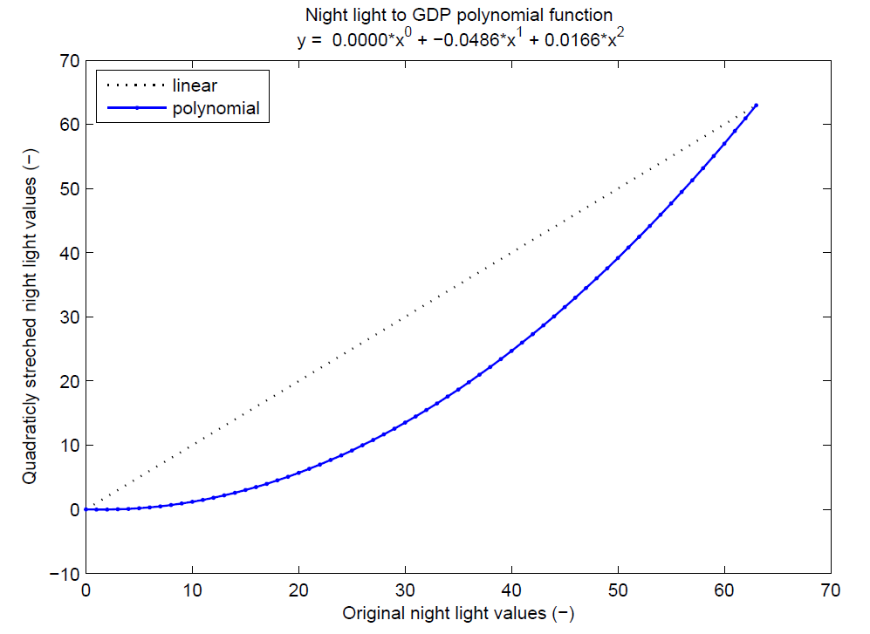

Figure 14: Second order polynomial transformation function (without y-indent) to define the relationship between night light intensities and asset values.

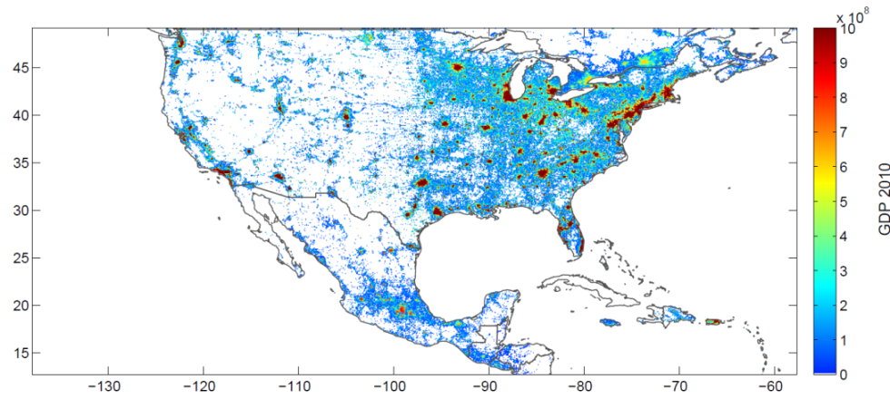Figure 15: GDP distributed according to night lights within one specific country, zoom to USA and Mexico. Bright spots are redder in the US than in Mexico, because Mexico has in total a lower GDP.

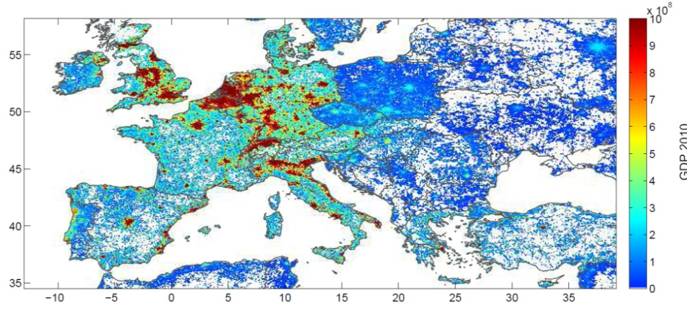

Figure 16: GDP distributed according to night lights within one specific country, zoom to Europe. See bright spot differences in Portugal versus Spain, or Germany versus Poland.

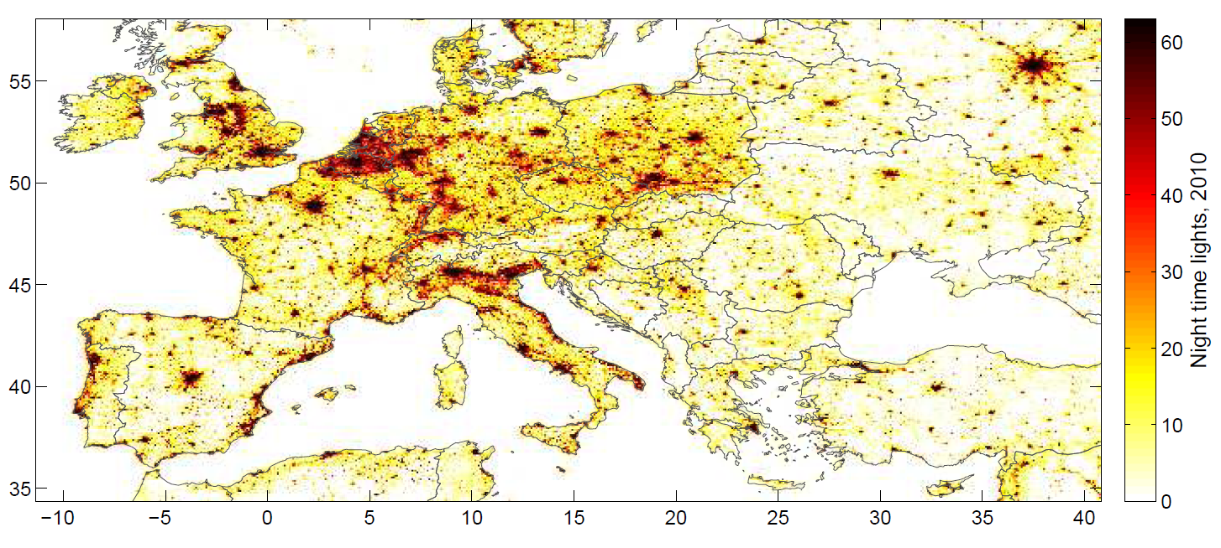

Figure 17: Night time lights in Europe.

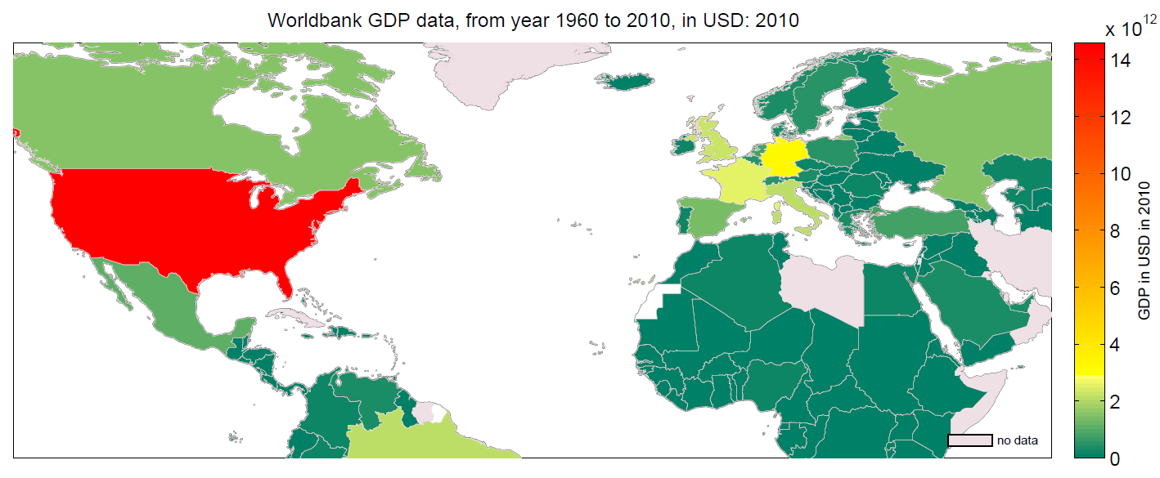

Figure 18: GDP per country in 2010.

## Create the centroids

### Define the resolution

In order to create centroids at a requested resolution the value distribution matrix needs to be downscaled accordingly.

To downscale the matrix to a required resolution we use the following function. The high_resolution_matrix is a matlab structure as described in values_distributed, namely with the fields .values, .lon_range, .lat_range, .resolution_x, .resolution_x. Specification is a string, to determine the value for the downscaled resolution matrix, with either summing up all values with the keyword 'sum', taking the average with keyword 'average' or taking the most counted value with keyword 'unique'.

|  |  |  |  |
| --- | --- | --- | --- |
| MATLAB call: | | | |
|  | [low_resolution_matrix, X, Y, resolution_km]= | climada_resolution_downscale (high_resolution_matrix, resolution_km, specification)  climada_resolution_downscale(values_distributed, 50, 'sum') | |
|  | low_resolution_matrix is a structure with the following fields | | |
|  |  | *.values* | *336x864 sparse matrix, distribution of values within the range indicated in lon_range and lat_range, ~50km resolution* |
|  |  | *.lon_range* | *Longitudinal range of masks, e.g. [-180 180]* |
|  |  | *.lat_range* | *Latitudinal range of masks, e.g. [-65 75]* |
|  |  | *.resolution_x* | *Resolution in x direction in degree, e.g. 0.4167°, corresponds to ~50km* |
|  |  | *.resolution_y* | *Resolution in y direction in degree, 0.4167°, corresponds to ~50km* |
|  |  | *.comment* | *e.g. nonlinear function, y = 0.0000*x^0 + -0.0817*x^1 + 0.0172*x^2, 46km, sum* |
|  | *X and Y are a helper matrices containing the longitude and latitude information, respectively for plotting the low_resolution_matrix.* | | |

### Cut out coastal areas (hollow out) and expand with a buffer zone

We create a buffer zone around the specified country in order to have centroids also in the oceans (e.g. to create nice wind field plots). Additionally the country area can be hollowed out to keep only the coastal areas. The buffer zone is characterized by the number of pixels into the sea. The coastal region to be kept is defined through the number of pixels as well. If no cut out is needed no_pixel_hollow can be set to 0.

|  |  |  |
| --- | --- | --- |
| MATLAB call: | | |
|  | matrix_buffer = | climada_mask_buffer_hollow (matrix, no_pixel_buffer, no_pixel_hollow, border_mask, check_figure, check_printplot, printname, cbar_label)  climada_mask_buffer_hollow(border_mask.mask{45},2,5) |
|  | matrix_bufferis a matrix masking 1 for on land, zero for sea, 2 for buffer. | |

|  |  |
| --- | --- |
|  |  |
| Figure 19: Mexico (no_pixel_hollow = 0), and buffer zone of about 80 km (8 pixels) around Mexico (grey). | Figure 20: Coastal Mexican areas (within 150 km from the coast, 15 pixels, turquoise) and buffer zone of about 80 km (8 pixels) around Mexico (grey). |

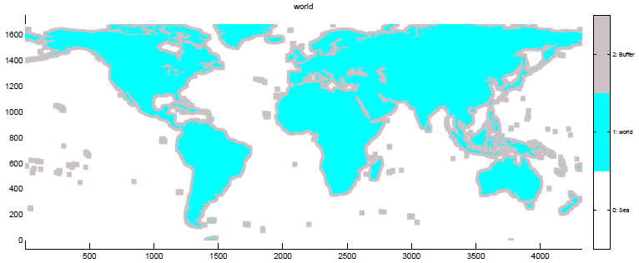

Figure 21: Entire world map with buffer of about 200 km (20 pixels).

### Create the centroids

This function creates the centroids on coastal land areas, within the buffer zone at the coast and on a coarser level further away, such as on sea and more distant from the coast. The resolution for coastal areas and buffer zone corresponds to the required input resolution. The regular grid has a five times coarser resolution, e.g. 50 km for resolution of coastal areas on 10 km.

|  |  |  |  |  |
| --- | --- | --- | --- | --- |
| MATLAB call: | | | | |
|  | centroids = | climada_matrix2centroid(matrix_buffer, lon_range, lat_range, country_name)  climada_resolution_downscale(values_distributed, 50, 'sum') | |
|  | low_resolution_matrix is a structure with the following fields | | |
|  |  | *.values* | *336x864 sparse matrix, distribution of values within the range indicated in lon_range and lat_range, ~50km resolution* |
|  |  | *.lon_range* | *Longitudinal range of masks, e.g. [-180 180]* |
|  |  | *.lat_range* | *Latitudinal range of masks, e.g. [-65 75]* |
|  |  | *.resolution_x* | *Resolution in x direction in degree, e.g. 0.4167°, corresponds to ~50km* |
|  |  | *.resolution_y* | *Resolution in y direction in degree, 0.4167°, corresponds to ~50km* |
|  |  | *.comment* | *e.g. nonlinear function, y = 0.0000*x^0 + -0.0817*x^1 + 0.0172*x^2, 46km, sum* |
|  | *X and Y are a helper matrices containing the longitude and latitude information, respectively for plotting the low_resolution_matrix.* | | | |

The centroids can be visualized on a map.

|  |  |  |
| --- | --- | --- |
| MATLAB call: | | |
|  | fig = | climada_plot_centroids(centroids, country_name, check_printplot, printname) |

|  |
| --- |
| Figure 22: Centroids in entire Mexico (turquoise, 10 km resolution), buffer zone (grey, 10 km resolution) and further away (on sea or in another country, orange, 50 km resolution). |
| Figure 23: Centroids in coastal Mexico (turquoise, 10 km resolution), buffer zone (grey, 10 km resolution) and further away (on sea or too far from the coast, orange, 50 km resolution). |

## Create the entity

### Base entity: assets sum up to 100 for a given country

The entity file contains all asset, vulnerability and adaptation measure data for a certain country or region. This is essentially an excel file with four tabs. As described in chapter 5, in the base entity, the sum of all assets within the entire country corresponds to 100. If only coastal areas are taken (hollowed out matrix), the sum of coastal assets is smaller than 100. This presents the basis for scaling up assets to any given value, such as the country's GDP for any given year or future year.

* Tab "assets": List of assets with longitude, latitude, asset value, damage function ID
* Tab "damagefunctions": A damage function describes how the asset responds to a given wind intensity. The damage function consists of two curves which put wind intensity in relation to mean damage degree and percentage of affected assets for a certain class of assets. There can be different damage functions depending on type and age of building.
* Tab "measures": Adaptation measures are available to avert todays and future risks. These can range from mangroves conservation, beach nourishment, to wind-resistant roofs and cross-bracing of houses, sandbags, construction of a seawall and risk transfer. This tab features a list of possible measures and its associated cost and the impacts on damage reduction. The impact of a measures is parameterized through the component of hazard reduction (e.g. mangroves reduce wind speed and wave heights), vulnerability reduction (e.g. wind-resistant roofs can withstand all damage up to a certain wind speed).
* Tab "discount": This tab contains the discount information, such as discount rate per year from today until the future (e.g. 2030 or 2050). This is used for discounting future loss reductions achieved through specific adaptation measures.

The base entity is saved as an excel file and is used in climada as a matlab structure. As in this module we create the assets only (longitude, latitude, asset values) of a given country or region, we use a wildcard entity with dummy values for the tabs damagefunctions, measures and discount. Based on this wildcard entity, we add the assets (location and values) to the entity matlab structure. In order to map a single asset to the closest calculation centroid, the assets are encoded to centroids. In core climada there is the function climada_assets_encode, that encodes the assets on the basis of the hazard, however here we encode the assets on the basis of the centroids.

|  |  |  |
| --- | --- | --- |
| MATLAB call: | | |
|  | entity_base = | climada_entity_base_assets_add(values_distributed,centroids, country_name, matrix_hollowout, X, Y, hollow_name) |

This function combines the following functions

To read the wildcard entity from excel file

|  |  |  |
| --- | --- | --- |
| MATLAB call: | | |
|  | entity_base = | climada_entity_read_wo_assets(entity_filename) |

To encode assets from the distributed value matrix

|  |  |  |
| --- | --- | --- |
| MATLAB call: | | |
|  | [entity_base.assets, centroids]= | climada_assets_encode_centroids(assets, centroids) |

Finally the assets within the entity can be visualized on a map.

|  |  |  |
| --- | --- | --- |
| MATLAB call: | | |
|  | fig = | climada_plot_entity_assets(entity,centroids, country_name, check_printplot, printname) |

|  |
| --- |
| Figure 24: Distribution of assets in Mexico (coastal areas and inland areas) on a 10 km resolution. The sum of all values corresponds to 100. |
| Figure 25: Distribution of assets in Mexican coastal areas only, on a 10 km resolution. The sum of all values corresponds to 39.9 as the inland areas omitted. |

### Entity with assets based on the country's GDP today

The assets need to be scale up from the base value of 100 (or less in the case of coastal areas only) to sum up to a country's GDP. This is done with the following function:

|  |  |  |
| --- | --- | --- |
| MATLAB call: | | |
|  | entity = | climada_entity_GDP(entity_base,GDP,year_start,centroids, borders, check_figure, check_printplot)  climada_entity_GDP(entity_100,GDP,2010,centroids) |

Note that the distribution of assets (look at the color scheme) is the same as in Figure 24 and Figure 25. Only the sum of all assets has changed.

|  |
| --- |
| Figure 26: Distribution of assets in Mexico, on a 10 km resolution. The sum of all asset values corresponds to the Mexican GDP in 2014. |
| Figure 27: Distribution of assets in Mexican coastal areas only, on a 10 km resolution. The sum of all values corresponds to 39.9% of the Mexican GDP in 2014 (inland areas omitted). |

### Future entity with assets based on the country's future GDP (e.g. 2030)

We use the GDP projection data from IMF for the years 2010 to 2017, from where we derive linear extrapolation formulas (see GDP chapter). Based on the linear extrapolation we project GDP for any given year in the future, e.g. 2030 or 2050. This is also used if the start year is after 2010, as the GDP data from the World Bank is only available up to 2010 in the excel sheet.

This following function scales the assets up based on GDP growth between two given periods. It includes the reading of GDP projection data, the extrapolation and the up scaling of the assets in the entity structure.

|  |  |  |
| --- | --- | --- |
| MATLAB call: | | |
|  | entity = | climada_entity_scaleup_GDP(entity,GDP_forecast,year_start, centroids, borders, check_figure, check_printplot) |

And in there the function climada_entity_scaleup_factor is used to scale up all assets within a given country with a given multiplicator.

|  |  |  |
| --- | --- | --- |
| MATLAB call: | | |
|  | entity = | climada_entity_scaleup_GDP(entity,GDP_forecast,year_start, centroids, borders, check_figure, check_printplot) |

### Select a specific region within a country

We can select a specific region within a country, and carve out assets and centroids within that region. The region can be defined through a polygon (vector), or is defined interactively by using the mouse.

|  |  |  |
| --- | --- | --- |
| MATLAB call: | | |
|  | [centroids, entity, polygon]= | climada_cut_out_GDP_entity(entity, centroids, polygon) |

polygon is a vector that characterizes the polygon, ie, polygon(:,1) are the longitudes, polygon (:,2) are the latitudes.

|  |
| --- |
| Figure 28: Define the region that is required with the mouse (see red lines). |
| Figure 29: Assets of within selected regions are still visible. All assets outside of the polygon are in grey. |
|  |

## Appendix

### Downscale resolution of original night light tif in ArcGIS

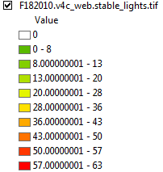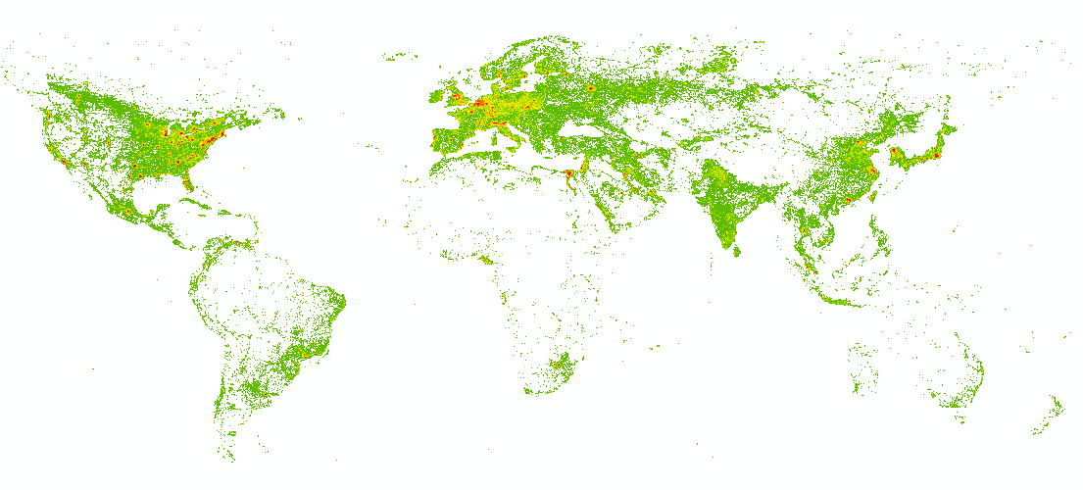

Figure 30: Night time lights in ArcGIS, 2010.

* Open georeferenced image in ArcGIS and save ArcGIS file
* Resample in ArcToolbox (search in ArcToolbox) from original resolution ~1km to ~10km cellsize (Output cell Size 0.083333, Resampling technique BILINEAR)

|  |  |  |
| --- | --- | --- |
|  |  |  |
| Figure 31: Resample cell resolution from ~1km (left) to ~10km (right). | | |

* Save stable nights lights as image

### Night light and GDP relationship

#### Literature

* U.S. Department of Commerce, Bureau of Economic Analysis

[www.bea.gov/regional/index.htm#gsp](http://www.bea.gov/regional/index.htm#gsp)

* Global estimates of marker and non-market values derived from nighttime satellite imagery, land cover, and ecosystem service valuation, Sutton and Costanza, 2002, Ecological Economics.

[www.sciencedirect.com/science/article/pii/S0921800902000976](http://www.sciencedirect.com/science/article/pii/S0921800902000976)

ln(GDP)= alpha + beta * ln(night light)

alpha = -4.25

beta = 1.05

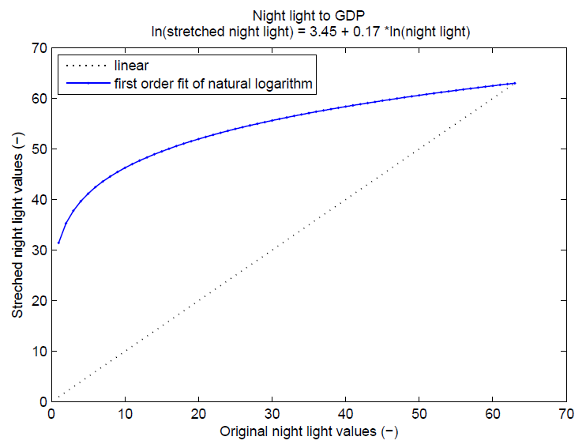

Figure 32: First order polynom fit to natural logarithmic relation between night light and GDP.

* Using luminosity data as a proxy for economic statistics, Chen and Nordhaus, 2011, PNAS.

[www.pnas.org/content/108/21/8589.full.pdf+html](http://www.pnas.org/content/108/21/8589.full.pdf+html)

[www.nsf.gov/discoveries/disc_summ.jsp?cntn_id=119737](http://www.nsf.gov/discoveries/disc_summ.jsp?cntn_id=119737)

Geographically based Economic data (G-Econ)

<http://gecon.yale.edu/usa>

* Night Lights and Economic Activity in India: A study using DMSP-OLS night time images, Bhandari and Roychowdhury, 2011

[www.google.ch/url?sa=t&rct=j&q=&esrc=s&frm=1&source=web&cd=4&cad=rja&ved=0CFoQFjAD&url=http%3A%2F%2Fusymposia.upm.my%2Findex.php%2FAPAN_Proceedings%2F32nd_APAN%2Fpaper%2Fdownload%2F137%2F96&ei=HUUzUNfeCcrStAaf6ICoAg&usg=AFQjCNG5fRnfSoK1j0SgnzcUIO1u1m-84w&sig2=3RiTp-r65OdRWOt7V58Cpg](http://www.google.ch/url?sa=t&rct=j&q=&esrc=s&frm=1&source=web&cd=4&cad=rja&ved=0CFoQFjAD&url=http%3A%2F%2Fusymposia.upm.my%2Findex.php%2FAPAN_Proceedings%2F32nd_APAN%2Fpaper%2Fdownload%2F137%2F96&ei=HUUzUNfeCcrStAaf6ICoAg&usg=AFQjCNG5fRnfSoK1j0SgnzcUIO1u1m-84w&sig2=3RiTp-r65OdRWOt7V58Cpg)

* Night time lights averaged by admin level 2 areas – indicator of GDP

[www.edenextdata.com/?q=content/night-time-lights-averaged-admin-level-2-areas-indicator-gdp-0](http://www.edenextdata.com/?q=content/night-time-lights-averaged-admin-level-2-areas-indicator-gdp-0)

* Shedding Light on the Global Distribution of Economic Activity, Gosh et al., 2010, The Open Geography Journal.

[www.ngdc.noaa.gov/dmsp/pubs/Ghosh_TOGEOGJ.pdf](http://www.ngdc.noaa.gov/dmsp/pubs/Ghosh_TOGEOGJ.pdf)

1. see climada_global.present_reference_year and climada_global.future_reference_year
2. See <https://github.com/davidnbresch/climada_module_country_risk>
3. In the past, also at [www.ngdc.noaa.gov/dmsp/data/web_data/v4composites/F182010.v4.tar](http://www.ngdc.noaa.gov/dmsp/data/web_data/v4composites/F182010.v4.tar) and [www.ngdc.noaa.gov/dmsp/downloadV4composites.html](http://www.ngdc.noaa.gov/dmsp/downloadV4composites.html)